**SOFTWARE REQUIREMENTS SPECIFICATION**

**FOR**

**HOSPITAL MANAGEMENT SYSTEM**

**PREPARED BY**

**NINAD PATIL (33)**

**SARATH SHANKARANARAYANAN (41)**

**MCA IIND SHIFT SEM 1**

**VESIT COLLEGE**

**INTRODUCTION**

Hospital are the essential part of our lives, providing best medical facilities to people suffering from various heart diseases, lungs diseases and someone want to do plastic surgery etc. It is necessary for the hospitals to keep track of its day-to-day activities & records of its patients for heart clinic, lungs clinic, plastic surgery that keep the hospital running smoothly & successfully.

But keeping track of all the activities and their records on paper is very cumbersome and error prone. It also is very inefficient and a time-consuming process Observing the continuous increase in population and number of people visiting the hospital. Recording and maintaining all these records is highly unreliable, inefficient and error-prone. It is also not economically & technically feasible to maintain these records on paper.

Thus, keeping the working of the manual system as the basis of our project. We have developed an automated version of the manual system, named as “Hospital Management System”. The main aim of our project is to provide a paper-less hospital up to 90%. It also aims at providing low-cost reliable automation of the existing systems. The system also provides excellent security of data at every level of user-system interaction and also provides robust & reliable storage and backup facilities. Hospital Management System (HMS) is a computer system that facilitates managing the functioning of the hospital or any medical set up. This system or software will help in making the whole functioning paperless. It integrates all the information regarding patients’ details, list of patients etc. into one software.

**It uses the concept of following C++ topics**:

* Loops
* Functions
* If Else
* Switch
* Classes

**The Objectives of this project is:**

* To develop to maintain the day to day state of admission/discharge of patients and critically ill patients
* To computerized all details regarding patient details
* Scheduling the operation of patient to make it convenient.
* The information of the patients should be kept up to date and their record should be kept in the system for historical purposes.

**EXITING SYSTEM**

* Hospitals currently use a manual system for the management and maintenance of critical information.
* The current system requires numerous paper forms, with data stores spread throughout the hospital management infrastructure. Often information is incomplete or does not follow management standards.
* Forms are often lost in transit between departments requiring a comprehensive auditing process to ensure that no vital information is lost.
* Multiple copies of the same information exist in hospital and may lead to inconsistencies in data in various data stores.

**PROBLEM DEFINATION**

* The hospital management system is designed for any hospital to replace their existing manual, paper-based system.
* The new system is to control the following information such as patient information, critical patient information and to delete the patient information, person to operate data.
* These services are to be provided in an efficient, cost effective manner, with the goal of reducing the time and resources currently required for such task.

**LIMITATION OF CURRENT SYSTEM**

* In few C++ compilers this software is not compatible.
* Its Compatible only in lower version of Code Blocks software.
* Online facility is not available.
* This system suitable for small hospital only.
* No built-in support for networking, sound and graphics.

**ADVANTAGES PROPOSED SYSTEM**

* This software reduces paper work.
* It is easy to handle patients record and products records for future.
* This software saves the time.
* Information of the patients stores permanently.

**FEASIBILITY STUDY**

As the name implies, a feasibility analysis is used to determine the viability of an idea, such as ensuring a project is legally and [technically feasible](https://en.wikipedia.org/wiki/Feasibility_study) as well as economically justifiable. It tells us whether a project is worth the investment—in some cases, a project may not be doable. There can be many reasons for this, including requiring too many resources, which not only prevents those resources from performing other tasks but also may cost more than an organization would earn back by taking on a project that isn’t profitable.

A well-designed study should offer a historical background of the business or project, such as a description of the product or service, accounting statements, details of operations and management, marketing research and policies, financial data, legal requirements, and tax obligations. Generally, such studies precede technical development and project implementation.

**Five Areas of Project Feasibility**

A feasibility analysis evaluates the project’s potential for success; therefore, perceived objectivity is an essential factor in the credibility of the study for potential investors and lending institutions. There are five types of feasibility study—separate areas that a feasibility study examines, described below.

* **Technical Feasibility**

This assessment focuses on the technical resources available to the organization. It helps organizations determine whether the technical resources meet capacity and whether the technical team is capable of converting the ideas into working systems. Technical feasibility also involves evaluation of the hardware, software, and other technical requirements of the proposed system. As an exaggerated example, an organization wouldn’t want to try to put Star Trek’s transporters in their building—currently, this project is not technically feasible.

* **Economic Feasibility**

This assessment typically involves a cost/ benefits analysis of the project, helping organizations determine the viability, cost, and benefits associated with a project before financial resources are allocated. It also serves as an independent project assessment and enhances project credibility—helping decision-makers determine the positive economic benefits to the organization that the proposed project will provide.

* **Legal Feasibility**

This assessment investigates whether any aspect of the proposed project conflicts with legal requirements like zoning laws, data protection acts or social media laws. Let’s say an organization wants to construct a new office building in a specific location. A feasibility study might reveal the organization’s ideal location isn’t zoned for that type of business. That organization has just saved considerable time and effort by learning that their project was not feasible right from the beginning.

* **Operational Feasibility**

This assessment involves undertaking a study to analyze and determine whether—and how well—the organization’s needs can be met by completing the project. Operational feasibility studies also examine how a project plan satisfies the requirements identified in the requirements analysis phase of system development.

* **Scheduling Feasibility**

This assessment is the most important for project success; after all, a project will fail if not completed on time. In scheduling feasibility, an organization estimates how much time the project will take to complete.

**FUNCTIONAL REQUIREMENTS**

1.SELECT REQUIRED DEPARTMENT.

2.ADD REGULAR PATIENT DETAILS.

3.ADD CRITICALLY ILL PATIENT DETAILS.

4.TAKE OUT PATIENT FOR OPERATION.

5.REMOVE PATIENT IF DISCHARGED OR DEAD.

6.LIST OF PATIENT.

7.CHANGE DEPARTMENT.

8.EXIT

**NON-FUNTIONAL REQUIREMENTS**

PERFORMANCE CRITERIA

* Time:

The most important thing in hospital management is that it should be time consuming

It should not take much time to add the details of the patient.

* User-friendly:

Our hospital management system should be more user friendly.The user interface should be kept simple and uncluttered.Since different hospitals may interact with this process so the project should be very easy to understand.

* Flexibility:

Our project should be so flexible that whenever we want to make changes in it

very easily it can be done.

* Extensibility:

It should be able to accommodate the variations like:

Different patient should be handled easily i.e critically patient should be added differenty so that we should know the difference.

* Portable:

Our project should be portable on any platform and available on websites easily

and at a faster speed than others.

* Reusable:

When the customer or patient comes to the hospital next time the data that is stored of the patient will be used its reduce the time of registration.

**OVERALL DESCRIPTION**

* **Product Perspective**
* **System Interface:** The system functions on C++environment. It basically accepts input from the user and gives the appropriate output.
* **User Interface:** User interface is designed using C++.
* **Memory Constraints:** 9-58 GB free hard disk space depending on edition and configuration, including space required for temporary files. Intel® Pentium® or compatible.

**SOFTWARE AND HARDWARE REQUIREMENTS**

**Software Requirements:** -

* Operating System: Windows XP
* Programming Language: C++
* Software Used: CodeBlocks, MS Word and Notepad++

**Hardware Requirements:** -

* Pentium-IV (Processor)
* 256 MB Ram
* 512 KB Cache Memory
* Hard Disk 10 GB

**WORK BREAKDOWN STRUCTURE**

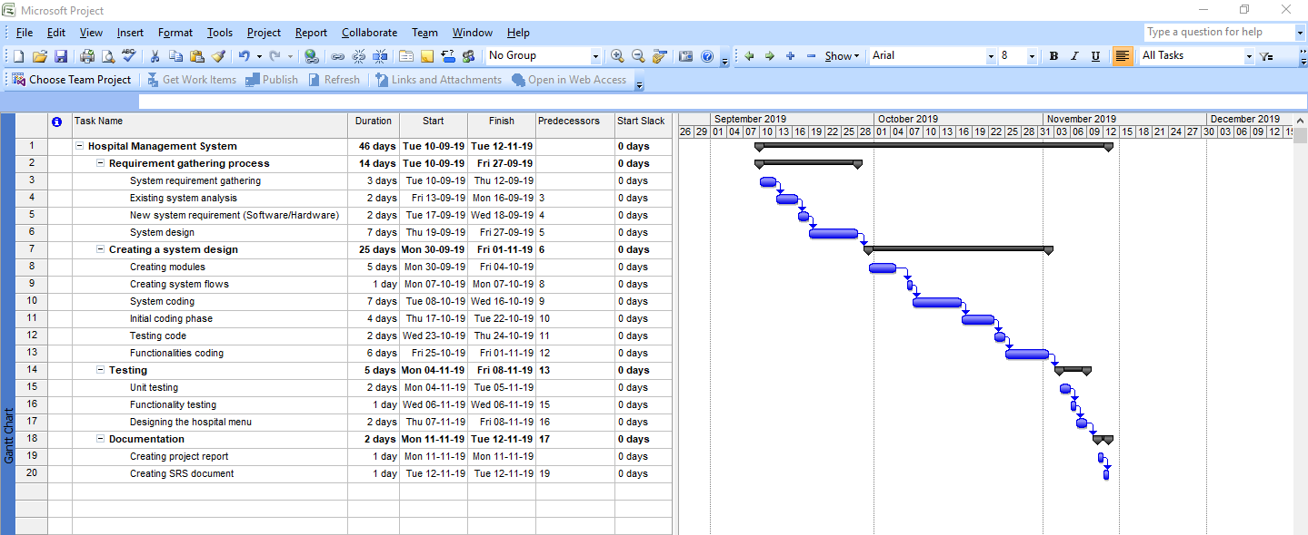

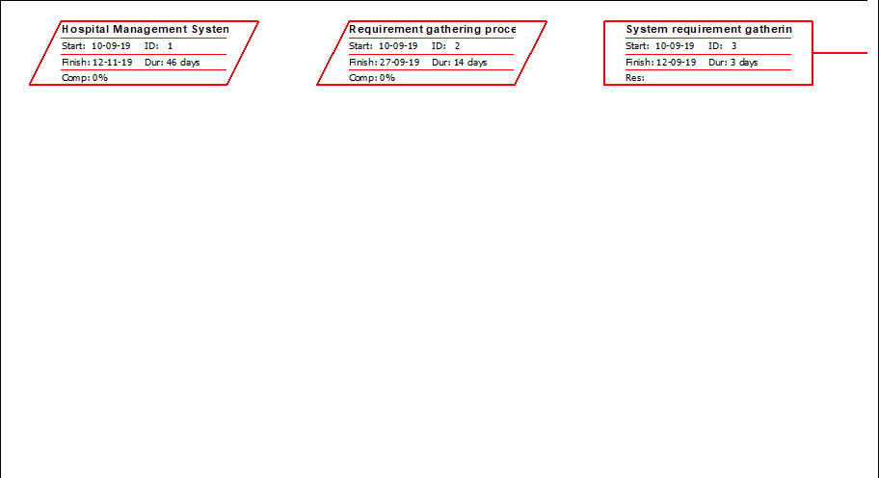

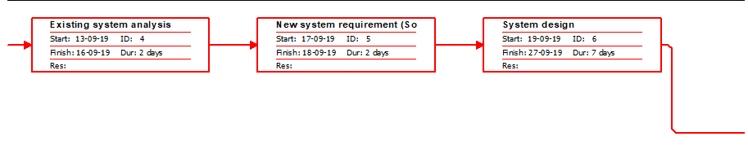 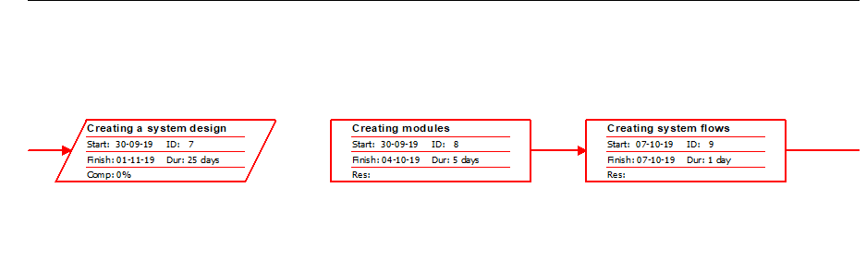

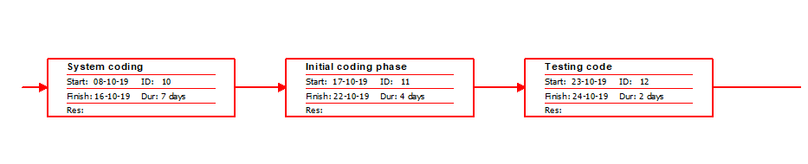

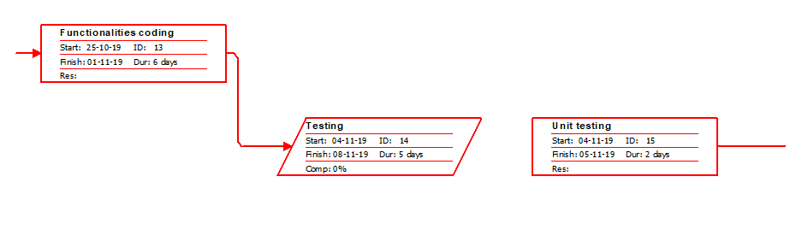

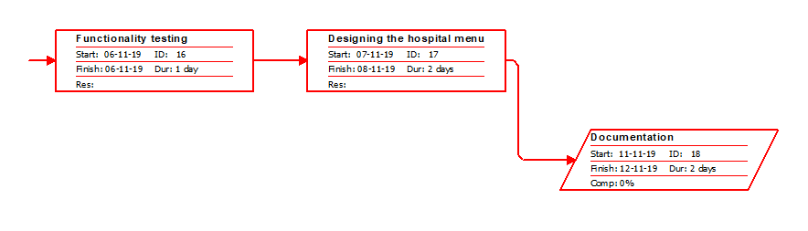

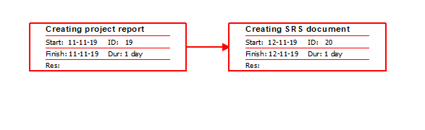

**SYSTEM FLOWCHARTS**

**OBJECT MODEL DIAGRAM (OMD)**

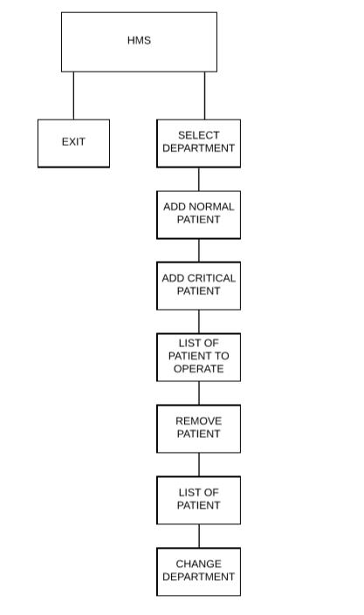

**DATA FLOW DIAGRAM**

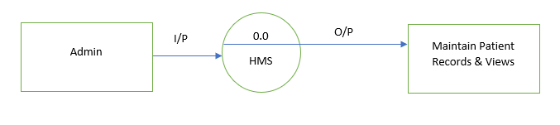

**0 Level DFD**

**Administrator Module DFD**

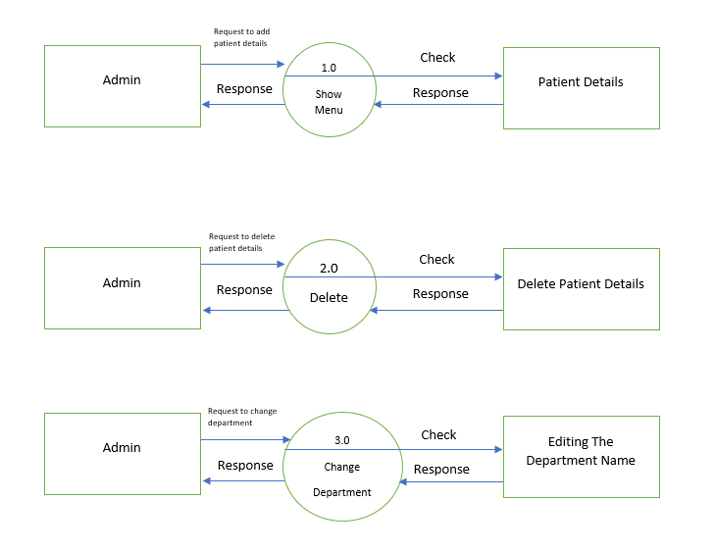

**1st Level DFD**

**TESTING**

Testing Methods: -

1. Unit Testing:

Unit testing involves the design of test cases that validate that validate that the internal program logic is functioning properly, and that program inputs produce valid output. All decision branches and internal codes flow should be validated. It is the testing of individual software units of the application. it is done after the completion of an individual unit before integration.

In our hospital management system (HMS) based on C++ programming language and we can add module in project

* Patient – Add new patient record and Modify, Delete, critically ill patient record functions.

Test result: all module are work properly with valid inputs

Test objectives: -

All field entries must work properly.

Features to be tested: -

1. Verify that the entries are of the correct format.
2. No duplicate entries should be allowed.
3. Functional Testing: -

Function tests provide systematic demonstrations that functions tested as available as specified by the business and technical requirements, system documentation, and user manuals.

Functional testing is centered on the following items:

1. Patient module: -

Valid Input: all identified classes of valid input must be accepted

E.g.: social security Number = “123” this input accepted.

Invalid Input: all invalid input must be rejected

E.g. double entry of register number input compiler rejected.

Function: all identified functions are working.

In patient module all functions (add record, modify record, delete record.) are properly working.

Output: identified classes of application outputs must be exercised.

All patient module functions are working properly and store data into system (file).

**MAINTAINANCE & IMPLEMENTATION**

Implementation is the stage of the project when the theoretical design is turned out into a working system. Thus, it can be considered to be the most critical stage in achieving a successful new system and in giving the user, confidence that the new system will work and be effective.

The implementation stage involves careful planning, investigation of the existing system and its constraints on implementation, designing of method to achieve changeover and evaluation of changeover methods.

**CONCLUSION**

Hospital Management System is a customizable and user-friendly software designed for small clinic which has administrator module which can enter new patient, view record and delete record. It’s also provides various clinic department such as heart, lungs. It has been designed to automate, manage and look after the overall processing of even very large data of patient. It is capable of managing patient details, patient appointment etc. Hospital Management System is offering a maximum stability, cost-effectiveness and usability. It provides the most flexible and adaptable standards for managing system software solutions for hospital.

**REFERENCES**

* Bibliography:

“The Complete Reference C++,4th Edition”, “Robert Lafore, SAMS Techmedia”

* Webliography:

<https://www.studytonight.com/cpp/>